3.2) Write a JavaScript that takes a number from one text field in the range of 0-999

and display it in other text field in words. If the number is out of range, it should

show “out of range” and if it is not a number, it should show “not a number”

message in the result box.

<html>

<head>

<meta charset="utf-8">

<title></title>

<script language="javascript">

function convert_number_to_words(number)

{

hyphen='-';

conjunction='and';

separator='.';

dictionary={0:'zero',1:'one',2:'two',3:'three',4:'four',5:'five',6:'six',7:'seven',8:'eight',

9:'nine',10:'ten',11:'eleven',12:'twelve',13:'thirteen',14:'fourteen',15:'fifteen',16:'sixteen',

17:'seventeen',18:'eighteen',19:'nineteen',20:'twenty',30:'thirty',40:'fourty',50:'fifty',

60:'sixty',70:'seventy',80:'eighty',90:'ninety',100:'hundred',};

if(number<0 || number>999)

{

alert("enter a number range between 0 and 999");

return "";

}

switch(true)

{

case(number<21):

string=dictionary[number];

break;

case(number<100):

tens=parseInt(number/10)*10;

units=number%10;

string=dictionary[tens];

if(units){

string+=hyphen+dictionary[units];

}

break;

case(number<1000):

hundreds=parseInt(number/100);

remainder=number%100;

string=dictionary[hundreds]+ ' ' +dictionary[100];

if(remainder){

string+=conjunction+convert_number_to_words(remainder);

}

break;

default:

break;

}

return string;

}a=prompt("Enter a number");

num=parseInt(a);

document.write(convert_number_to_words(num));

</script>

</head>

<body bgcolor="darkturquoise">

<h2 align="center"><i>WELCOME TO JAVASCRIPT</i></h2>

</body>

</html>

Output:

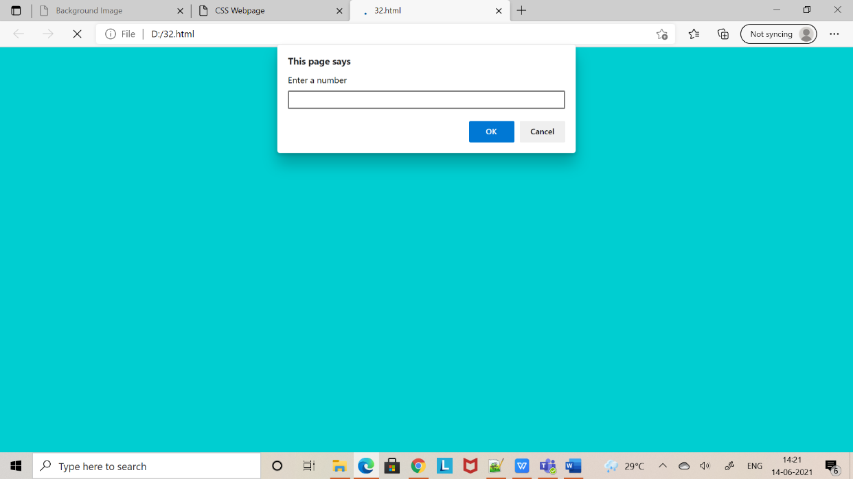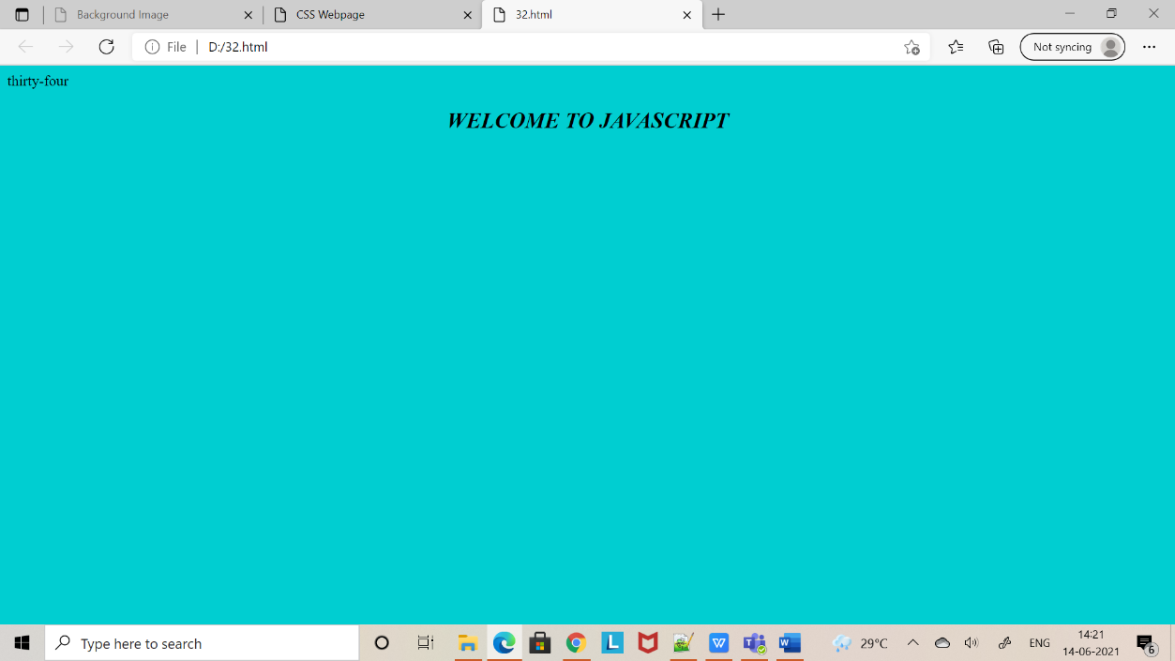

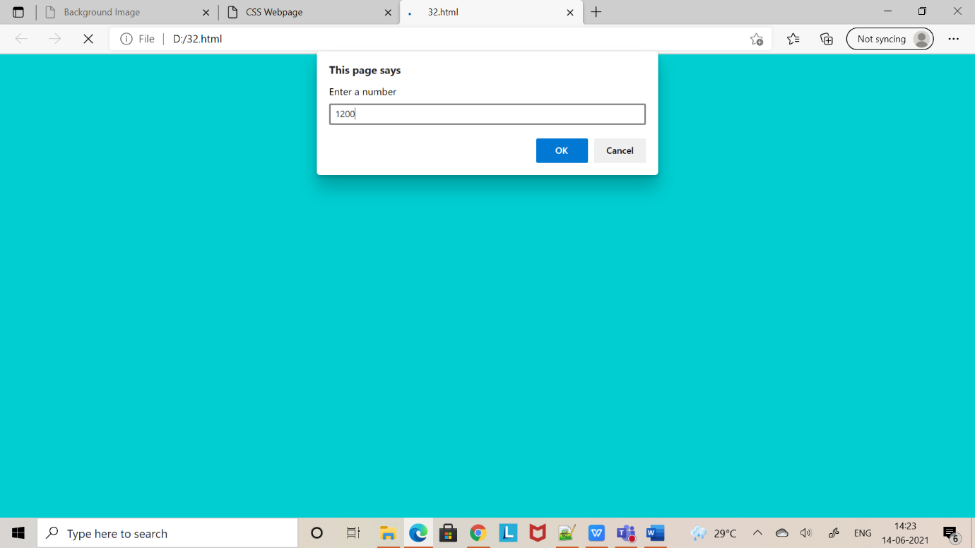

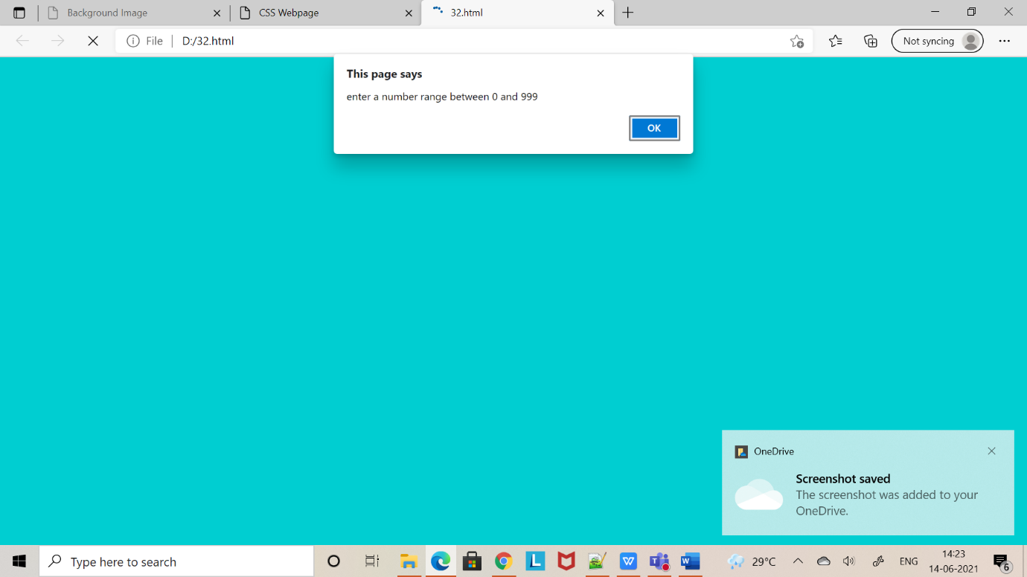

NAME : Sonali Sahu

18A91A0556